Project Initiation
Project initiation is the starting point of a project where the project idea is evaluated at a high level and the organization gives formal authorization to proceed.
It answers fundamental questions such as:
- Why is the project needed?
- What business problem or opportunity does it address?
- What should the project achieve?
- Is the project worth doing?
- Who will sponsor the project?
- Who will manage the project?
- Who are the key stakeholders?
- What are the high-level requirements?
- What are the major risks, assumptions, constraints, cost, and timeline?
- Who has authority to approve the project?
Simple example
Suppose a company wants to develop a new mobile banking application.
During initiation, the company does not create the detailed database design, write code, or prepare detailed sprint plans.
Instead, it determines:
“We need a mobile banking application to increase digital transactions and improve customer experience. The project will cost approximately $2 million, take around 12 months, and will be sponsored by the CIO.”
If management approves this, the project is formally authorized.
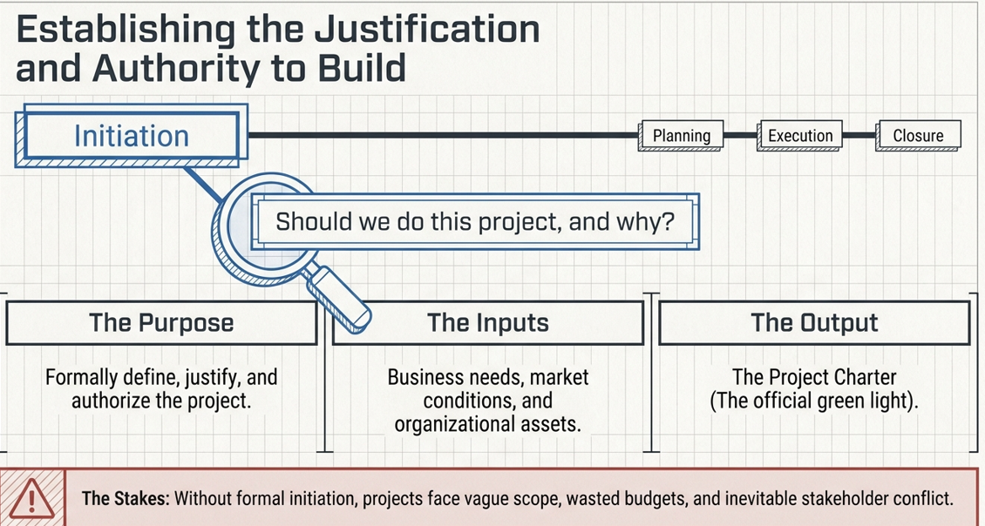
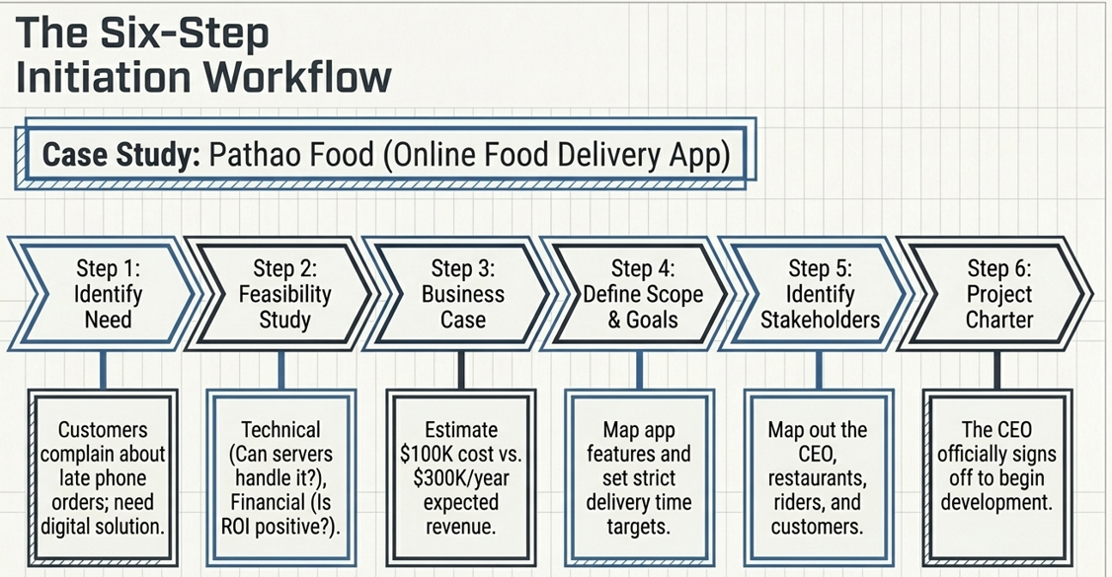
Key Steps in Project Initiation
Project initiation is the first major phase of a project. It determines whether the project should be started, why it is needed, what it should achieve, who is involved, and who has authority to proceed.
A simple flow is:
Identify Need
↓
Feasibility Study
↓
Business Case
↓
Define Scope & Goals
↓
Identify Stakeholders
↓
Develop Project Charter
↓
Project Authorized
↓
Planning Phase

1. Identify the Need
What is it?
The first step is to identify why the project is required.
A project usually starts because of:
- A business problem
- A customer requirement
- A new business opportunity
- A regulatory requirement
- A technological change
- A market demand
- An organizational improvement
Questions to ask
- What problem are we trying to solve?
- Why is this problem important?
- What opportunity are we trying to capture?
- What happens if we don't do the project?
- Who is experiencing the problem?
Example
A bank discovers that customers are increasingly using mobile banking, but its existing mobile application is outdated.
Need:
Develop a modern mobile banking application to improve customer experience and increase digital transactions.
Output
A clearly defined problem, need, or opportunity.

2. Conduct a Feasibility Study
What is it?
A feasibility study determines whether the proposed project is practical and achievable.
In simple words:
Can we actually do this project?
The organization examines whether it has the necessary technology, money, people, time, and capabilities.
Major feasibility areas
Area | Key Question
Technical | Can we build it with available technology?
Financial | Can we afford it?
Operational | Can the organization operate it?
Legal/Regulatory | Is it legally permitted?
Schedule | Can we complete it on time?
Resource | Do we have the required people and skills?
Example
For the mobile banking project:
- Do we have mobile developers?
- Can the application integrate with the core banking system?
- Is the $2 million budget available?
- Can it be developed within 12 months?
- Can security and regulatory requirements be satisfied?
Possible conclusion
The feasibility study may conclude:
The project is technically and financially feasible and can be completed within 12 months.
Or:
The project is not feasible because the required technology is unavailable or the expected cost is too high.
Output
Feasibility assessment/recommendation
→ Proceed
→ Modify
→ Reject
→ Investigate further

3. Develop the Business Case
What is it?
The business case explains why the organization should invest in the project.
It compares the expected benefits, costs, risks, and alternatives.
Simple definition
Business Case = Why should we invest in this project?
Typical contents
- Business problem/opportunity
- Project objectives
- Expected benefits
- Estimated cost
- Expected revenue/savings
- Risks
- Assumptions
- Alternatives
- Return on investment (ROI)
- Recommendation
Example
Suppose a bank estimates:
Item | Amount
Development cost | $2 million
Expected annual savings | $500,000
Expected additional revenue | $1 million/year
Expected customer growth | 20%
Project duration | 12 months
The business case might conclude:
The mobile banking project is expected to generate significant financial and customer benefits and is therefore recommended for approval.
Important distinction
Feasibility Study:
Can we do it?
Business Case:
Should we do it?
This is a very useful distinction.

4. Define Scope and Goals
Once the organization decides that the project is worth pursuing, the project needs a high-level definition of what it will accomplish.
A. Define Project Goals
Goals describe the desired overall result.
Example:
Improve customers' digital banking experience.
B. Define Project Objectives
Objectives should be more specific and measurable.
Example:
Launch an Android and iOS mobile banking application within 12 months with support for balance checking, fund transfers, and bill payments.
SMART objective example
Increase mobile banking transactions by 30% within six months of launching the new application.
This is:
- Specific
- Measurable
- Achievable
- Relevant
- Time-bound

C. Define High-Level Scope
In Scope
- Mobile login
- Account balance
- Fund transfer
- Bill payment
- Transaction history
- Notifications
Out of Scope
- New ATM infrastructure
- Replacement of the core banking system
- International banking services
Why scope is important
It establishes the boundary of the project.
PROJECT
┌───────────────────┐
│ IN SCOPE │
│ │
│ Features │
│ Deliverables │
│ Requirements │
│ │
└───────────────────┘

Outside the boundary
= OUT OF SCOPE
At initiation, scope is generally high level. Detailed scope is developed during planning.

5. Identify Stakeholders
What is it?
Identify everyone who:
- Can influence the project
- Can affect the project
- Can be affected by the project
- Has an interest in the project
Example: Mobile Banking Project
PROJECT
│
┌───────────────┼────────────────┐
↓ ↓ ↓
Sponsor Customers Project Team
│ │
↓ ├── Developers
CIO ├── QA
├── BA
└── Security
Other stakeholders may include:
- Bank management
- Product owner
- Operations team
- Compliance team
- Government/regulators
- Vendors
- Customer support
- Business users
Analyze stakeholders
You should also consider their:
- Interest
- Influence/power
- Expectations
- Impact on the project
- Potential concerns
Output
Stakeholder Register
Example:
Stakeholder | Interest | Influence
CIO/Sponsor | High | High
Product Owner | High | High
Customers | High | Medium
Developers | High | Medium
QA | High | Medium
Regulator | Medium | High

6. Develop the Project Charter
This is one of the most important steps in project initiation according to PMBOK.
What is a Project Charter?
The Project Charter is the document that formally authorizes the project.
It gives the project manager authority to use organizational resources for project activities.
Simple definition
Project Charter = Official authorization to start the project
You can think of it as the project's birth certificate.

What does the Project Charter contain?
Typically, it includes high-level information such as:
- Project name
- Project purpose
- Business need
- Business objectives
- High-level requirements
- High-level scope
- Major deliverables
- Major milestones
- High-level budget
- High-level risks
- Assumptions
- Constraints
- Project sponsor
- Project manager
- Stakeholders
- Approval/authorization
Example
Project: Mobile Banking Application
Purpose: Improve digital banking services.
Objective: Launch Android and iOS applications within 12 months.
Budget: $2 million.
Major risks: Security, regulatory compliance, integration.
Sponsor: CIO.
Project Manager: John.
Approval: Approved by CIO/authorized sponsor.
Once the charter is approved:
The project is officially authorized.

Complete Example
Let's put all six steps together.
Scenario
A bank wants to build a new mobile banking application.
Step 1 — Identify Need
Problem: Existing mobile application is outdated.
Need: Improve digital banking experience.
↓
Step 2 — Feasibility Study
The organization checks:
- Technology ✔
- Budget ✔
- Resources ✔
- Schedule ✔
- Legal/regulatory requirements ✔
Conclusion: Project is feasible.
↓
Step 3 — Business Case
Expected:
- Increased digital transactions
- Improved customer satisfaction
- Reduced branch workload
- Increased revenue
Conclusion: Benefits justify the investment.
↓
Step 4 — Define Scope & Goals
Goal:
Improve digital banking experience.
In scope:
- Login
- Balance
- Fund transfer
- Bill payment
- Transaction history
Out of scope:
- Core banking replacement
- ATM replacement
↓
Step 5 — Identify Stakeholders
Identify:
- CIO
- Product owner
- Customers
- Developers
- QA
- Security
- Compliance
- Operations
- Regulators
↓
Step 6 — Develop Project Charter
Document:
"Develop and launch a secure mobile banking application within 12 months with a budget of $2 million."
Sponsor approves the charter.
↓
PROJECT AUTHORIZED ✅

Summary: Input → Process → Output
Step | Main Question | Key Activities | Main Output
1. Identify Need | Why do we need it? | Identify problem/opportunity | Need/problem statement
2. Feasibility Study | Can we do it? | Technical, financial, operational analysis | Feasibility recommendation
3. Business Case | Should we do it? | Analyze benefits, cost, risks, alternatives | Business case
4. Define Scope & Goals | What should we achieve? | Define goals, objectives, high-level scope | High-level scope & objectives
5. Identify Stakeholders | Who matters? | Identify and analyze stakeholders | Stakeholder Register
6. Project Charter | Are we authorized? | Formally define and authorize project | Project Charter
Easy way to remember
NEED → CAN → SHOULD → WHAT → WHO → AUTHORIZE
Or:
IDENTIFY NEED
↓
Can we do it?
↓
FEASIBILITY
↓
Should we do it?
↓
BUSINESS CASE
↓
What will we do?
↓
SCOPE & GOALS
↓
Who is involved?
↓
STAKEHOLDERS
↓
Who authorizes it?
↓
PROJECT CHARTER
↓
PROJECT STARTS
Project Selection Methods
Project selection is the process of evaluating different project proposals and deciding which projects an organization should invest in, prioritize, and execute.
Organizations usually have limited budget, people, time, and technology, so they cannot undertake every proposed project.
For example, an IT company may have these proposals:
- Develop a new mobile banking application
- Upgrade an existing ERP system
- Build an AI chatbot
- Migrate applications to the cloud
- Develop a new HR management system
Project selection methods help management answer:
“Which project will provide the best value to the organization?”
Common project selection methods include:
- NPV – Net Present Value
- ROI – Return on Investment
- Scoring Model
- Payback Period
- Cost-Benefit Analysis
- Strategic Alignment
- Risk Analysis
Let's look at the three important methods in detail.

1. NPV – Net Present Value
What is NPV?
Net Present Value (NPV) is a financial project selection technique that calculates the present value of future cash inflows and outflows of a project.
The basic idea is:
Money received today is worth more than the same amount received in the future.
This is called the time value of money.
For example:
If someone gives you $10,000 today, you can invest it and earn interest.
So receiving $10,000 today is generally better than receiving $10,000 five years from now.

NPV Formula
Where:
- Cash Flowₜ = cash flow in a particular year
- r = discount rate
- t = year
- Initial Investment = money invested at the beginning

Simple IT Project Example
Suppose an IT company is considering developing an AI-powered customer support chatbot.
Initial investment
$100,000
Expected cash benefits:
Year | Expected Cash Benefit
Year 1 | $40,000
Year 2 | $50,000
Year 3 | $60,000
Assume the discount rate is 10%.
Present value
Year 1:
Year 2:
Year 3:
Total present value:
Therefore:
Decision
Because NPV is positive, the project is financially attractive.
Positive NPV → Generally accept
Negative NPV → Generally reject
When comparing otherwise similar projects, the project with the higher NPV is generally preferred.

NPV Example: Comparing Two IT Projects
Suppose an organization has two projects.
Project A – AI Chatbot
Investment = $100,000
Expected NPV = $22,765
Project B – Mobile Application
Investment = $150,000
Expected NPV = $40,000
If the projects have similar strategic importance and risk:
Project | Investment | NPV | Decision
AI Chatbot | $100K | $22.8K | Good
Mobile App | $150K | $40K | Better financially
Therefore, Project B would normally be preferred based purely on NPV.
Important point
NPV does not mean:
"Choose the project with the highest revenue."
It means:
Choose the project that creates the highest present value after considering the time value of money.

2. ROI – Return on Investment
What is ROI?
ROI (Return on Investment) measures how much return a project generates compared with the amount invested.
It answers:
“For every dollar we invest, how much return do we get?”
ROI is one of the simplest and most commonly used project selection methods.

ROI Formula
Where:
Therefore:

IT Project Example – CRM Implementation
Suppose a company wants to implement a new CRM system.
Costs
- Software: $40,000
- Implementation: $30,000
- Training: $10,000
- Maintenance: $20,000
Total cost:
Expected total benefit over the evaluation period:
$160,000
Therefore:
ROI:
Interpretation
A 60% ROI means the project generates a net return equal to 60% of the investment.

ROI Comparison of IT Projects
Suppose management has three projects:
Project | Cost | Benefit | Net Benefit | ROI
CRM | $100K | $160K | $60K | 60%
AI Chatbot | $80K | $120K | $40K | 50%
Mobile App | $200K | $280K | $80K | 40%
Based purely on ROI:
CRM > AI Chatbot > Mobile App
So CRM would rank first.

NPV vs ROI
This is an important distinction.
NPV | ROI
Measures value in monetary terms | Measures return as a percentage
Considers time value of money | Basic ROI may not
Produces a dollar value | Produces a percentage
Useful for investment decisions | Useful for comparing returns
More financially sophisticated | Simple and easy to understand
Example
Project A:
- Investment = $100K
- Profit = $50K
- ROI = 50%
Project B:
- Investment = $1M
- Profit = $400K
- ROI = 40%
Based on ROI:
Project A wins.
But Project B generates $400K profit, compared with only $50K from Project A.
Therefore, management should not select projects based on ROI alone.

3. Scoring Model
What is a Scoring Model?
A scoring model is a project selection technique where projects are evaluated against multiple criteria, and each criterion is given a score and often a weight.
Unlike NPV and ROI, scoring models can evaluate both:
Financial factors
- Cost
- ROI
- Revenue
- Savings
Non-financial factors
- Strategic alignment
- Customer satisfaction
- Risk
- Innovation
- Regulatory compliance
- Technical feasibility
- Business value
This makes scoring models particularly useful for IT project selection.

Why Use a Scoring Model?
Consider two projects.
Project A
- High ROI
- Low strategic importance
- High technical risk
Project B
- Moderate ROI
- Very important to company strategy
- Low risk
- Required for regulatory compliance
If we look only at ROI, Project A might win.
But management may actually need Project B.
A scoring model allows multiple factors to be considered together.

Weighted Scoring Model
A common approach is:
Then:

IT Project Example
Suppose an IT company is considering three projects:
Project A – AI Customer Support
Project B – Legacy System Modernization
Project C – Mobile Application
Management defines these criteria:
Criteria | Weight
Strategic Alignment | 25%
Business Value | 25%
ROI | 20%
Technical Feasibility | 15%
Risk | 10%
Customer Impact | 5%
Total | 100%
Each project receives a score from 1 to 5.
- 1 = Very Poor
- 2 = Poor
- 3 = Average
- 4 = Good
- 5 = Excellent

Scoring
Criteria | Weight | AI Support | Legacy Modernization | Mobile App
Strategic Alignment | 25% | 5 | 4 | 4
Business Value | 25% | 4 | 5 | 4
ROI | 20% | 5 | 3 | 4
Technical Feasibility | 15% | 3 | 4 | 5
Risk | 10% | 3 | 4 | 4
Customer Impact | 5% | 5 | 3 | 5
Now calculate weighted scores.
AI Support
Using percentages:
Legacy Modernization
Mobile Application

Final Ranking
Rank | Project | Score
🥇 1 | AI Customer Support | 4.25
🥈 2 | Mobile Application | 4.20
🥉 3 | Legacy Modernization | 4.00
Therefore, according to this scoring model:
AI Customer Support should receive the highest priority.

How Scoring Models Are Used in Real Organizations
A company may create a project selection scorecard such as:
Strategic Alignment → 25%
Financial Value → 20%
Customer Value → 15%
Technical Feasibility → 15%
Risk → 10%
Regulatory/Compliance → 10%
Innovation → 5%
Each proposed project is scored against these criteria.
This creates a standardized and transparent way of comparing projects.

NPV vs ROI vs Scoring Model
Factor | NPV | ROI | Scoring Model
Main purpose | Financial value | Return percentage | Overall project attractiveness
Financial | ✅ Strong | ✅ Strong | ✅ Can include
Time value of money | ✅ Yes | ❌ Usually no | ❌ Usually no
Non-financial factors | ❌ Limited | ❌ Limited | ✅ Yes
Strategic alignment | ❌ | ❌ | ✅
Risk | ❌ | ❌ | ✅
Customer impact | ❌ | ❌ | ✅
Easy to calculate | Medium | Easy | Easy–Medium
Best for | Investment decisions | Return comparison | Multi-factor decisions

Simple Real-Life IT Example
Imagine a company has $500,000 available for IT projects.
It has four proposals:
- AI Customer Support
- Mobile Banking App
- ERP Modernization
- Cybersecurity Upgrade
Management could use all three methods.
Step 1 – ROI
Calculate which projects provide the best financial return.
Step 2 – NPV
Calculate which projects create the greatest present financial value.
Step 3 – Scoring Model
Evaluate:
- Strategic importance
- ROI
- NPV
- Customer value
- Risk
- Technical feasibility
- Compliance
- Innovation
Then rank the projects.
Final decision
Management should not automatically select the project with the highest ROI.
For example, a cybersecurity project might have a low direct ROI but be mandatory because of regulatory or security requirements.
Therefore:
Project selection is a business decision, not merely a financial calculation.
Key Takeaway
NPV asks:
“How much value does this project create in today's money?”
ROI asks:
“How much return do we get compared with what we invest?”
Scoring Model asks:
“Considering financial and non-financial factors, which project is the best overall choice?”
A good project selection process often uses all three together:
Project Proposals → Financial Analysis (NPV/ROI) → Scoring Model → Risk & Strategic Review → Prioritization → Project Selection

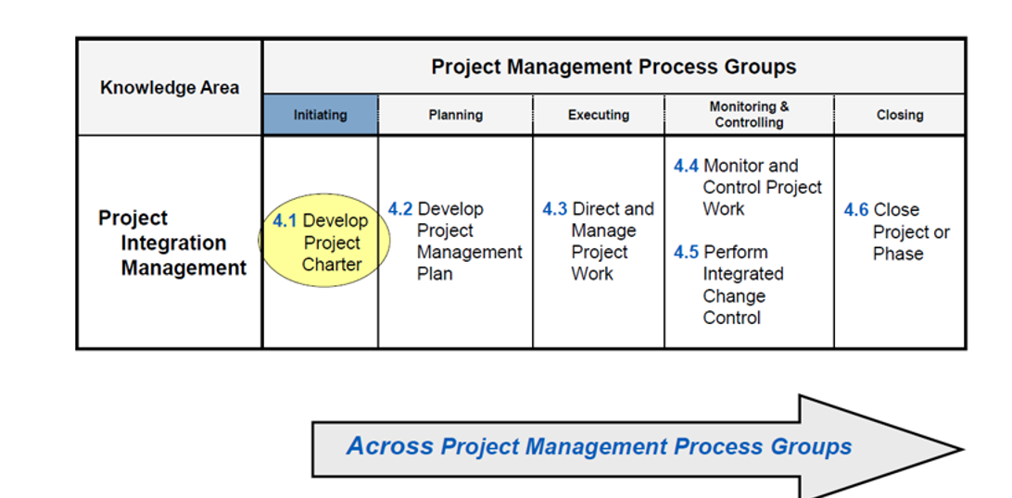
1. What is a Project Charter?
A Project Charter is a formal document that officially authorizes the existence of a project and gives the Project Manager authority to use organizational resources for the project.
In simple words:
Project Charter = Official permission to start the project.
It answers the basic questions:
- Why are we doing the project?
- What are we going to achieve?
- Who is involved?
- Who is the Project Manager?
- What is the high-level scope?
- How much is the project expected to cost?
- When is it expected to finish?
- What are the major risks and assumptions?
PMBOK perspective
The Project Charter is the key output of the Develop Project Charter process in the Initiating Process Group.
The charter is created before detailed project planning.

2. Who Approves the Project Charter?
The Project Charter is generally approved/authorized by the Project Sponsor.
Project Sponsor
The Sponsor is the person who:
- Provides or secures funding
- Supports the project at the organizational level
- Provides high-level direction
- Helps remove organizational barriers
- Authorizes the project
- Approves the Project Charter
What about the Project Manager?
The Project Manager usually helps develop the charter, but does not normally approve their own charter.
A simple relationship is:
Business Need
↓
Project Proposal
↓
Project Sponsor
↓
Develop Project Charter
↓
Project Charter
↓
Sponsor approves/authorizes
↓
PROJECT OFFICIALLY STARTS
↓
Project Manager gets authority
Important
The exact approval authority can vary by organization.
For example:
- Small project → Department Head
- Large project → Project Sponsor
- Strategic project → Executive Sponsor / Steering Committee
- Government project → Authorized senior authority
But from a PMBOK perspective, the sponsor is the key person who authorizes the project through the charter.

3. Who Creates the Project Charter?
The Project Sponsor typically initiates and sponsors the charter, while the Project Manager and relevant stakeholders may contribute to its development.
For example:
Sponsor
│
├── Business Need
├── Business Case
│
↓
Project Manager + Key Stakeholders
│
↓
Develop Project Charter
│
↓
Sponsor Approval

4. Major Components of a Project Charter
A Project Charter is a high-level document. It does not contain the detailed project plan.
Typical components include:
1. Project Title
Name of the project.
Example:
AI-Powered Customer Support System

2. Project Purpose / Business Need
Why is the project being undertaken?
Example:
The company currently handles 70% of customer queries manually, resulting in long response times and high support costs.

3. Project Objectives
What does the project want to achieve?
Objectives should ideally be SMART.
Example:
Reduce average customer response time from 8 hours to less than 2 hours within six months of implementation.

4. High-Level Requirements
What must the project deliver?
Example:
- AI chatbot
- Web interface
- Customer authentication
- Knowledge base integration
- Human-agent handoff
- Reporting dashboard

5. High-Level Scope
Defines what is included and excluded.
In scope:
- Web-based chatbot
- FAQ integration
- Customer support integration
Out of scope:
- Mobile application
- Voice-based AI assistant
- International language support

6. Key Deliverables
The major outputs of the project.
Example:
- AI chatbot
- Knowledge base
- Admin dashboard
- API integration
- User documentation
- Production deployment

7. High-Level Milestones
Major dates or stages.
Milestone | Target
Project kickoff | January
Requirements completed | February
Prototype | March
Development completed | May
Testing completed | June
Production launch | July

8. High-Level Budget
Estimated project cost.
Example:
Estimated Budget: $250,000
This is a high-level estimate, not the detailed cost baseline.

9. Key Stakeholders
People or groups affected by or involved in the project.
Example:
- Project Sponsor
- Project Manager
- Product Owner
- Development Team
- QA Team
- IT Operations
- Customer Support Team
- Customers
- Senior Management

10. Project Manager
The charter identifies who will manage the project.
Example:
Project Manager: John Smith
It may also specify the Project Manager's authority.
Example:
The Project Manager is authorized to coordinate project resources, manage the project team, and make decisions within the approved project constraints.

11. High-Level Risks
Major risks known at the beginning.
Example:
- AI response accuracy may be insufficient.
- Integration with legacy systems may be difficult.
- Data privacy/security risks.
- Lack of AI expertise.
- Project may exceed the estimated budget.

12. Assumptions
Things believed to be true for planning purposes.
Example:
- Required APIs will be available.
- Required technical resources will be provided.
- Business stakeholders will be available for requirements validation.

13. Constraints
Known limitations.
Example:
- Budget limited to $250,000
- Project must be completed within 7 months
- Must comply with organizational security policies
- Limited availability of AI engineers

14. Success Criteria
How will we know the project is successful?
Example:
- Response time reduced by 75%
- Customer satisfaction ≥ 90%
- AI answers accuracy ≥ 95%
- Production deployment completed by July
- Budget variance ≤ 5%

15. Approval / Authorization
The final section identifies who authorizes the project.
Example:
Role | Name | Approval
Project Sponsor | Jane Smith | Approved
Project Manager | John Smith | Acknowledged

5. Complete Example of Project Charter
Project: AI Customer Support System
Project Purpose
The company wants to reduce customer support response time and operational costs by implementing an AI-powered customer support system.
Business Need
Currently, customer support agents manually handle most repetitive customer queries. This results in long response times and increased operational costs.
Project Objective
Develop and deploy an AI-powered customer support chatbot that can automatically resolve at least 60% of common customer queries within 7 months, while maintaining customer satisfaction of at least 90%.
High-Level Scope
In Scope
- AI chatbot
- Customer authentication
- Knowledge-base integration
- Customer support ticket integration
- Admin dashboard
- Analytics and reporting
- Security testing
Out of Scope
- Voice assistant
- Mobile application
- International language support
Major Deliverables
- AI chatbot
- Knowledge base
- Integration APIs
- Admin dashboard
- Testing reports
- User documentation
- Production deployment
Major Milestones
Milestone | Target
Project initiation | January
Requirements | February
Prototype | March
Development | May
Testing | June
Production launch | July
Estimated Budget
$250,000
Key Stakeholders
- Executive Sponsor
- Project Manager
- Product Owner
- Development Team
- QA Team
- IT Operations
- Customer Support
- Customers
Major Risks
- AI accuracy may be lower than expected.
- Integration with legacy systems may take longer.
- Security/privacy issues may arise.
- Shortage of AI specialists.
Assumptions
- Required technical resources will be available.
- Existing APIs can support integration.
- Business users will provide timely feedback.
Constraints
- Maximum budget: $250,000
- Maximum duration: 7 months
- Must comply with company security requirements.
Success Criteria
The project will be considered successful if:
- At least 60% of common queries are automatically resolved.
- Customer satisfaction reaches at least 90%.
- Project is delivered within the approved budget.
- Production deployment occurs by July.
Authorization
Project Sponsor: Jane Smith
Project Manager: John Smith
The Project Sponsor approves the Project Charter and formally authorizes the project to begin.

6. Project Charter vs Project Management Plan
This is a very important PMBOK distinction.
Project Charter | Project Management Plan
Authorizes the project | Guides project execution
Created during initiation | Developed during planning
High-level | Detailed
Defines high-level scope | Defines detailed scope
High-level budget | Detailed cost baseline
High-level milestones | Detailed schedule
Identifies Project Manager | Defines how project will be managed
Approved by Sponsor/authorized authority | Approved according to organizational governance
Answers "Should we start?" | Answers "How will we execute?"
Easy way to remember
Project Charter = Permission to start
Project Management Plan = Plan for how to execute
BUSINESS NEED
↓
BUSINESS CASE
↓
PROJECT CHARTER
↓
PROJECT IS AUTHORIZED
↓
PROJECT MANAGER
↓
PROJECT MANAGEMENT PLAN
↓
PROJECT EXECUTION
↓
DELIVERABLE
↓
BUSINESS VALUE
One-line exam definition
A Project Charter is a formal document that authorizes a project and gives the Project Manager authority to apply organizational resources to project activities.
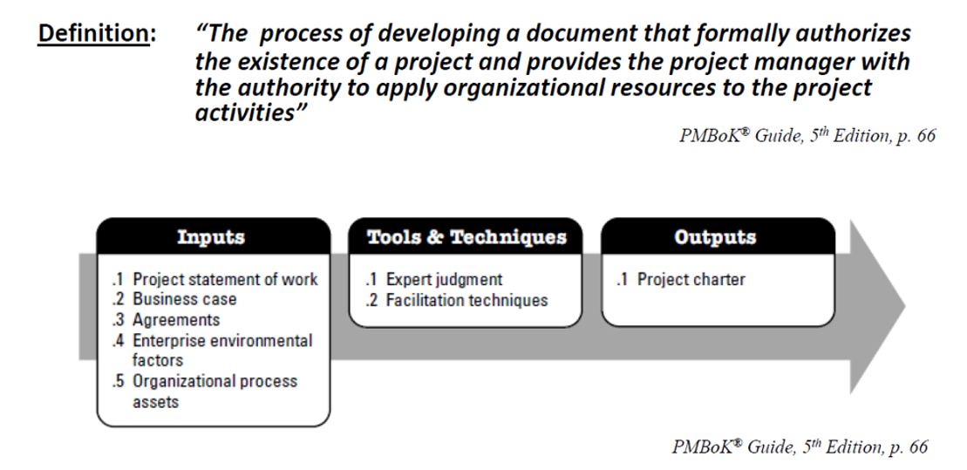
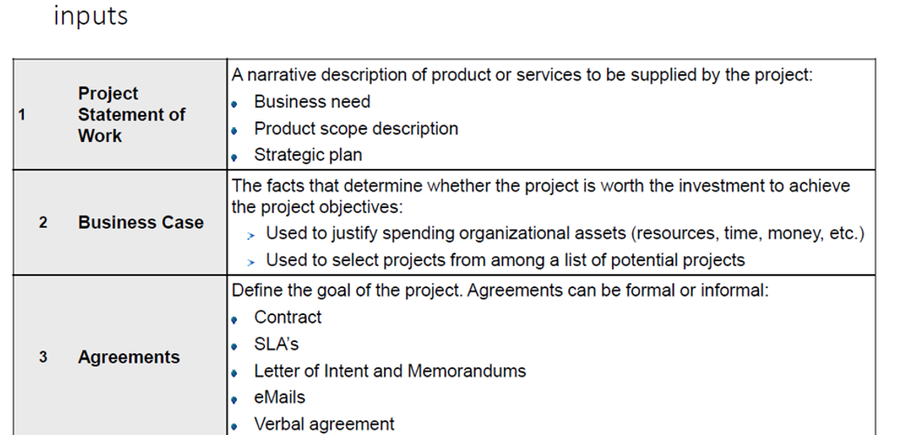
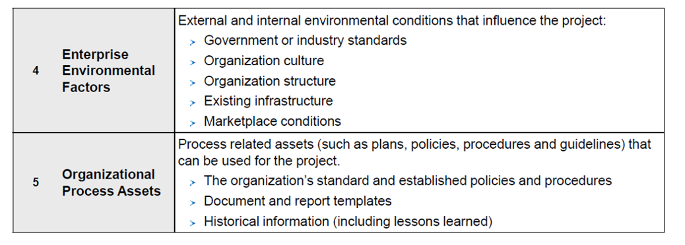
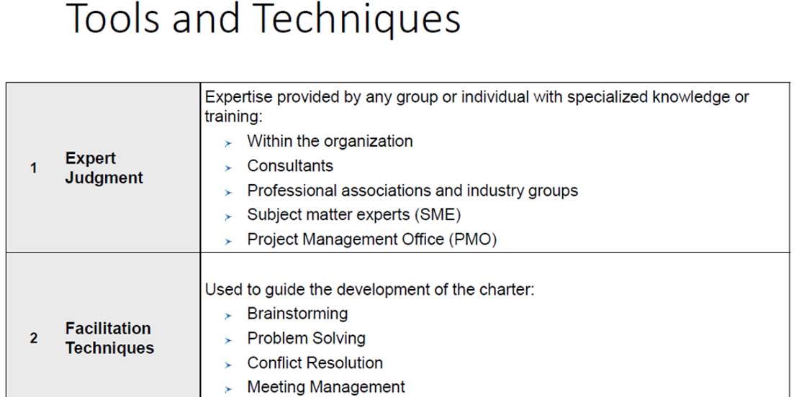
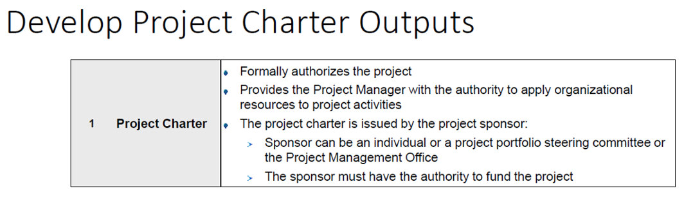
Enterprise Environmental Factors (EEF)
What is EEF?
Enterprise Environmental Factors (EEF) are the internal and external conditions that influence a project but are generally outside the direct control of the project team.
Simple meaning:
EEF = Factors around the project that affect how the project is managed.

Types of EEF
1. Internal EEF
Factors within the organization.
Examples:
- Organizational culture
- Company structure
- Existing technology
- Infrastructure
- Employee skills
- Resource availability
- Company policies
Example:
A company has limited experienced AI developers → the AI project may need to hire external experts.

2. External EEF
Factors outside the organization.
Examples:
- Government regulations
- Laws
- Market conditions
- Economic conditions
- Industry standards
- Competitors
- Political environment
Example:
New data-privacy regulations are introduced → an IT project must modify its security and data-handling requirements.

Quick Comparison
Type | Meaning | Example
Internal EEF | Conditions inside the organization | Limited skilled developers
External EEF | Conditions outside the organization | Government regulations
Easy way to remember
Internal EEF = Inside the organization
External EEF = Outside the organization
Organizational Process Assets (OPA)
What is OPA?
Organizational Process Assets (OPA) are the existing processes, policies, procedures, templates, knowledge, and historical information within an organization that can be used to help manage a project.
Simple meaning:
OPA = Things the organization already has that can help us manage the project.

Types of OPA
1. Processes, Policies & Procedures
These are the organization's established ways of doing work.
Examples:
- Project management methodology
- Quality procedures
- Risk management procedures
- Security policies
- Change management procedures
Example:
A company requires every software project to follow its standard QA and security process.

2. Organizational Knowledge & Information
These are existing knowledge and information from previous work.
Examples:
- Previous project reports
- Lessons learned
- Historical cost and schedule data
- Previous risk registers
- Project performance data
- Knowledge repositories
Example:
A previous software project took 8 months and faced database-integration problems. The new Project Manager uses this information while planning the new project.

Quick Comparison
Type | Meaning | Example
Processes, Policies & Procedures | Standard ways of working | Project management methodology
Knowledge & Information | Existing organizational knowledge | Lessons learned from previous projects
Easy way to remember
OPA = What the organization already has and can reuse.
EEF → Conditions that influence the project
OPA → Organizational assets that help manage the project
Stakeholder & Stakeholder Management – PMBOK
1. What is a Stakeholder?
A stakeholder is an individual, group, or organization that can affect, be affected by, or perceive itself to be affected by a project.
Simple meaning
Stakeholder = Anyone who has an interest in or can influence the project.
IT Project Example
For an Online Banking Application, stakeholders may include:
- Project Sponsor
- Project Manager
- Developers
- QA Team
- Customers
- Bank Management
- Security Team
- Operations Team
- Government/Regulatory bodies
- External vendors

2. What is Stakeholder Management?
Stakeholder Management is the process of identifying stakeholders, understanding their expectations and influence, communicating with them, and managing their engagement throughout the project.
Simple meaning
Stakeholder Management = Identify → Understand → Engage → Communicate → Manage
The goal is to build support, trust, and cooperation and reduce resistance or conflicts.

3. Why is Stakeholder Management Necessary?
Good stakeholder management is important because stakeholders can strongly influence project success.
Main reasons:
- Understand expectations
  - Know what stakeholders want from the project.
- Get support
  - Gain management and stakeholder support.
- Reduce conflicts
  - Identify disagreements early.
- Improve communication
  - Ensure the right information reaches the right people.
- Manage resistance
  - Help stakeholders accept changes.
- Make better decisions
  - Stakeholders provide business and technical knowledge.
- Increase project success
  - Stakeholder support improves the chances of achieving project objectives.
Example
Suppose an organization develops a new HR system but does not involve HR employees.
After development, HR discovers that important leave-management features are missing.
➡️ The project may face rework, delays, additional cost, and user resistance.
Good stakeholder management would involve HR from the beginning.

4. How to Do Stakeholder Management?
A simple approach is:
1. Identify Stakeholders
↓
2. Analyze Stakeholders
↓
3. Plan Engagement
↓
4. Engage Stakeholders
↓
5. Monitor & Adjust Engagement
Step 1: Identify
Find everyone who can affect or be affected by the project.
Step 2: Analyze
Understand:
- Their interest
- Their influence/power
- Their expectations
- Their attitude
- Their concerns
Step 3: Plan Engagement
Decide:
- How to communicate with them
- How often to communicate
- What information they need
- How to handle their concerns
Step 4: Engage
Actively communicate and work with stakeholders.
Examples:
- Meetings
- Workshops
- Demonstrations
- Reviews
- Presentations
- Emails
- Surveys
Step 5: Monitor
Stakeholder attitudes can change during the project.
Therefore:
Monitor stakeholder engagement continuously and change the strategy when required.

5. What is a Stakeholder Register?
A Stakeholder Register is a document that records information about project stakeholders.
It is created during stakeholder identification and updated throughout the project.
Typical information
- Stakeholder name/role
- Organization/department
- Interest
- Influence/power
- Expectations
- Concerns
- Current engagement level
- Desired engagement level
- Communication needs

6. Stakeholder Register Example – IT Project
Project: Online Banking Application
Stakeholder | Role | Power | Interest | Current Engagement | Desired Engagement
CEO | Sponsor | High | High | Supportive | Leading
Project Manager | Manages project | High | High | Leading | Leading
Customers | End users | Medium | High | Neutral | Supportive
Developers | Build system | Medium | High | Supportive | Leading
QA Team | Testing | Medium | High | Supportive | Leading
Security Team | Security approval | High | High | Neutral | Supportive
Operations | Deployment/support | Medium | Medium | Neutral | Supportive
Regulator | Compliance | High | Medium | Neutral | Supportive
This register helps the Project Manager determine who needs more attention and what kind of engagement is required.

7. What is Stakeholder Engagement?
Stakeholder engagement means actively involving stakeholders in the project in a way that addresses their needs, expectations, concerns, and influence.
Simple meaning
Engagement = How actively and effectively we involve stakeholders in the project.
Engagement is more than simply sending emails.
For example:
Low engagement
"We send the customer a monthly project status report."
High engagement
"We invite the customer to sprint reviews, demonstrate features, collect feedback, and incorporate valid feedback into future work."

8. Stakeholder Engagement Levels
PMBOK commonly describes stakeholder engagement using five levels:
Level | Meaning
Unaware | Does not know about the project
Resistant | Knows about it but opposes it
Neutral | Aware but neither supports nor opposes
Supportive | Supports the project
Leading | Actively involved in making the project successful
Example
Suppose a company introduces a new AI-based employee performance system.
An employee may initially be:
Unaware → Resistant → Neutral → Supportive
The Project Manager's job is to develop appropriate engagement strategies to move important stakeholders toward the desired engagement level.

9. Stakeholder Engagement Strategies
The strategy depends on the stakeholder's power, interest, attitude, and influence.
A useful tool is the Power–Interest Grid.
 | High Interest | Low Interest
High Power | Manage Closely | Keep Satisfied
Low Power | Keep Informed | Monitor

A. Manage Closely
High Power + High Interest
These stakeholders can significantly influence the project.
Strategy:
- Frequent communication
- Involve in important decisions
- Regular meetings
- Demonstrations
- Address concerns quickly
Example:
Project Sponsor

B. Keep Satisfied
High Power + Low Interest
They have high authority but don't need detailed information every day.
Strategy:
- Provide important updates
- Keep them satisfied
- Escalate major issues
- Avoid unnecessary details
Example:
Senior executive who sponsors several projects.

C. Keep Informed
Low Power + High Interest
They care strongly about the project but have limited decision-making power.
Strategy:
- Regular updates
- Meetings
- Demonstrations
- Feedback sessions
Example:
End users of a new HR application.

D. Monitor
Low Power + Low Interest
They have limited influence and interest.
Strategy:
- Monitor their involvement
- Provide information when necessary
- Don't spend excessive effort
Example:
Employees who are only indirectly affected by the project.

10. Complete IT Example
Project: New Employee Management System
Suppose the stakeholders are:
Stakeholder | Power | Interest | Strategy
CEO/Sponsor | High | High | Manage Closely
HR Manager | High | High | Manage Closely
Employees | Low | High | Keep Informed
IT Operations Manager | High | Low | Keep Satisfied
Other Departments | Low | Low | Monitor
Engagement actions
CEO/Sponsor:
- Monthly executive review
- Budget/status reporting
- Major issue escalation
HR Manager:
- Weekly requirements meeting
- Sprint demonstrations
- Requirement approval
Employees:
- Surveys
- User testing
- Training
- Feedback sessions
IT Operations:
- Deployment planning
- Security/infrastructure reviews
- Major technical updates

Stakeholder Management – Easy Formula
Remember:
IDENTIFY → ANALYZE → PLAN → ENGAGE → MONITOR
And:
Stakeholder Register = Who are they?
Stakeholder Engagement = How involved are they?
Engagement Strategy = What will we do to manage their involvement?
One-line exam definitions
Stakeholder:
An individual, group, or organization that can affect, be affected by, or perceive itself to be affected by a project.
Stakeholder Management:
The systematic process of identifying stakeholders, understanding their needs and influence, and managing their engagement throughout the project.
Stakeholder Register:
A document containing information about project stakeholders and their interests, influence, expectations, and engagement.
Stakeholder Engagement:
The process of involving stakeholders appropriately to gain their support, manage expectations, and address their concerns.
PROJECT CHARTER
Project: AI-Powered Customer Support System
Item | Details
Sponsor | Director of Operations
Project Manager | Project Manager
Duration | 7 Months
Budget | $250,000
Project Type | IT / AI Project
1. Business Need
Automate repetitive customer queries to reduce support costs, improve response time, and increase customer satisfaction.
2. Objectives
- Automate 60% of common queries.
- Reduce response time by 70%.
- Achieve 90% customer satisfaction.
- Complete within 7 months and $250,000.
3. In Scope
- AI chatbot
- Knowledge-base integration
- CRM/ticketing integration
- Customer and admin interfaces
- Testing and security
- Deployment
- Training and documentation
4. Out of Scope
- Mobile application
- Voice-based assistant
- New CRM development
- Multi-language support
- Replacement of human support agents
5. Major Deliverables
- AI chatbot
- Integrated support system
- Admin dashboard
- Reports/analytics
- Test and security reports
- Production deployment
- User documentation
6. Major Milestones
Requirements → Design → Prototype → Development → Testing → UAT → Production → Closure
7. Key Stakeholders
- Project Sponsor
- Project Manager
- Product Owner
- Development & AI/ML Teams
- QA & Security Teams
- IT Operations
- Customer Support
- Customers
8. Major Risks
- AI accuracy issues
- Integration complexity
- Security/privacy issues
- Resource shortage
- Schedule delays
- Poor user adoption
9. Assumptions
- Required resources are available.
- CRM APIs are available.
- Business stakeholders provide timely feedback.
- Required infrastructure and approvals are available.
10. Constraints
- Budget: $250,000
- Duration: 7 months
- Limited AI resources
- Must follow security and organizational policies.
11. Success Criteria
- 60% query automation
- 70% reduction in response time
- ≥90% customer satisfaction
- Delivered within approved scope, budget, and schedule
- Successful UAT and business acceptance
12. Authorization
The Project Sponsor approves the Project Charter, formally authorizing the project and giving the Project Manager authority to use organizational resources.
Sponsor: __________
Project Manager: __________
Date: __________

